Laboratory Manual

for

Computer Organization and Assembly Language

|  |  |
| --- | --- |
| Course Instructors |  |
| Lab Instructor(s) |  |
| Section |  |
| Semester |  |

**Department of Computer Science**

# COAL Lab 9 Manual

|  |
| --- |
| Objectives:  * A flash back to Irvine32 Library * Runtime stack * Modular approach, Defining & Using Procedures * Problems & Assignments |

# 9.1 Introduction

1. How to divide programs into manageable units by calling subroutines;
2. How programming languages use the runtime stack to track subroutine calls.

# 9.2 Irvine32 library

|  |  |  |  |  |
| --- | --- | --- | --- | --- |
| **Sr. No** | **Command** | **Input** | **Output** | **Function** |
| 1. | **ReadChar** | User | AL | Waits for a single character to be typed at the keyboard and returns the character. |
| 2. | **ReadDec** | EAX | Reads an unsigned 32-bit decimal integer from the keyboard, terminated by the Enter key. |
| 3. | **ReadHex** | Reads a 32-bit hexadecimal integer from the keyboard, terminated by the Enter key. |
| 4. | **ReadInt** | Reads a 32-bit signed decimal integer from the keyboard, terminated by the Enter key. |
| 5. | **ReadString** | EDX = offset buffer  ECX = Sizeof buffer | EAX=No. of character entered  buffer = string | Reads a string from the keyboard, terminated by the Enter key. |
| 6. | **WaitMsg** | Nill | Nill | Displays a message and waits for a key to be pressed. |
| 7. | **WriteBin** | EAX | Console | Writes an unsigned 32-bit integer to the console window in ASCII binary format. |
| 8. | **WriteBinB** | EAX= value EBX= type | Writes a binary integer to the console window in byte, word, or doubleword format. |
| 9. | **WriteChar** | AL | Writes a single character to the console window. |
| 10. | **WriteDec** | EAX | Writes an unsigned 32-bit integer to the console window in decimal format. |
| 11. | **WriteHex** | Writes a 32-bit integer to the console window in hexadecimal format. |
| 12. | **WriteHexB** | EAX= value EBX= type | Writes a byte, word, or doubleword integer to the console window in hexadecimal format. |
| 13. | **WriteInt** | EAX | Writes a signed 32-bit integer to the console window in decimal format. |
| 14. | **WriteString** | EDX= offset string | Writes a null-terminated string to the console window. |

# 9.3 Runtime Stack

We concentrate specifically on the runtime stack. It is supported directly by hardware in the CPU, and it is an essential part of the mechanism for calling and returning from procedures. Most of the time, we just call it the stack.

The runtime stack is a memory array managed directly by the CPU, using the ESP register, known as the stack pointer register. The ESP register holds a 32-bit offset into some location on the stack. We rarely manipulate ESP directly; instead, it is indirectly modified by instructions such as CALL, RET, PUSH, and POP. ESP always points to the last value to be added to, or pushed on, the top of stack.

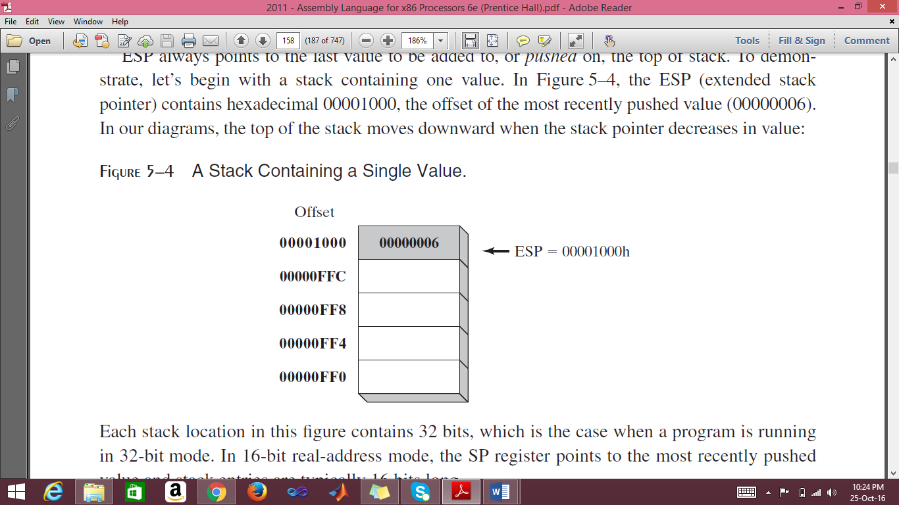

**Applications**

There are several important uses of runtime stacks in programs:

1. A stack makes a convenient temporary save area for registers when they are used for more than one purpose. After they are modified, they can be restored to their original values.
2. When the CALL instruction executes, the CPU saves the current subroutine’s return address on the stack.
3. When calling a subroutine, you pass input values called arguments by pushing them on the stack.
4. The stack provides temporary storage for local variables inside subroutines.

**Instructions**

|  |  |  |
| --- | --- | --- |
| Command | Syntax | Function |
| **PUSH** | PUSH *reg/mem32*  PUSH *imm32* | A 32-bit operand causes ESP to be decremented by 4. |
| **POP** | POP *reg/mem16*  POP *reg/mem32* | Copies the contents of the stack element pointed to by ESP into a 16- or 32-bit destination operand and then increments ESP by 2 (word size) by 4 (dword size). |
| **PUSHFD** | pushfd | Pushes the 32-bit EFLAGS register on the stack. |
| **POPFD** | popfd | Pops the stack into EFLAGS |
| **PUSHAD** | pushad | Pushes all of the 32-bit general-purpose registers on the stack in the following order: EAX, ECX, EDX, EBX, ESP (value before executing PUSHAD), EBP, ESI, and EDI. |
| **POPAD** | popad | Pops the same registers off the stack in reverse order |

# 9.4 Defining and Using Procedures

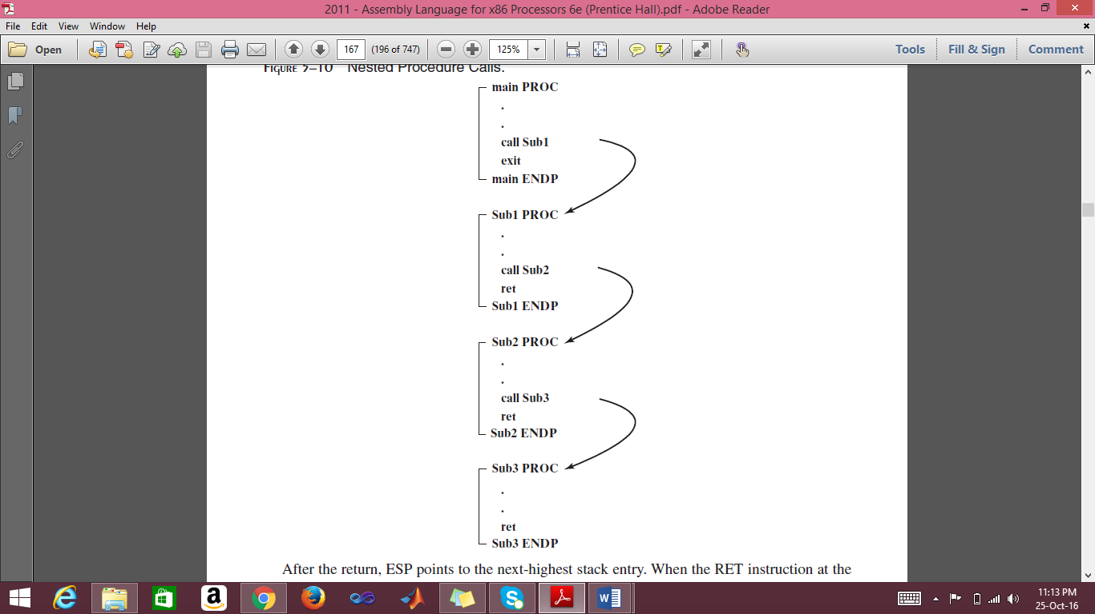

### USES Operator

The USES operator, coupled with the PROC directive, lets you list the names of all registers modified within a procedure. USES tells the assembler to do two things: First, generate PUSH instructions that save the registers on the stack at the beginning of the procedure. Second, generate POP instructions that restore the register values at the end of the procedure.

ArraySum PROC **USES esi ecx**

mov eax,0 ; set the sum to zero

L1:

add eax,[esi] ; add each integer to sum

add esi,TYPE DWORD ; point to next integer

loop L1 ; repeat for array size

ret ; sum is in EAX

ArraySum ENDP

## Problem(s) / Assignment(s)

|  |  |
| --- | --- |
| **Discussion & Practice** | **Estimated completion time: 1 hr, 30 mins** |

|  |  |
| --- | --- |
| **Problem 9.1:** *Random Number Generator*  Write a program that should,   1. Randomly generate 10 unsigned integers in the range 0 to 4,294,967,294. 2. Next, it generates 10 signed integers in the range -50 to +49.   Use builtin procedures *Random32*, *Randomize*, *RandomRange* as shown below.  Follow modular approach i.e., make a procedure RAND_U for unsigned integers and RAND_S for signed integers. Your main should only be used for calling the procedures.    **Sample output:**  3221236194 2210931702 974700167 367494257 2227888607  926772240 506254858 1769123448 2288603673 736071794  -34 +27 +38 -34 +31 -13 -29 +44 -48 -43 | **Estimated completion time:20 mins** |

|  |  |  |  |
| --- | --- | --- | --- |
| Command | Input | Output | Function |
| **Random32** | Seed | EAX | Returns a 32-bit random integer. |
| **Randomize** |  |  | Initializes the starting seed value of the Random32 and RandomRange procedures. The seed equals the time of day, accurate to 1/100 of a second. |
| **RandomRange** | EAX= n | EAX | Produces a random integer within the range of 0 to n-1. |

|  |  |
| --- | --- |
| **Problem 9.2:** *Reversing a String*  Write a program using LOOP instruction with index addressing that copies a string from source to target, reversing the character order in the process. Use the following variables:  **source BYTE "This is the source string",0**  **target BYTE SIZEOF source DUP('#')**  Use DumpMem to display the string. If your program works correctly, it will display the following sequence of hexadecimal bytes:  67 6E 69 72 74 73 20 65 63 72 75 6F 73 20 65 68  74 20 73 69 20 73 69 68 54  Use Stack to implement this program. | **Estimated completion time:15 mins** |

**You are done with your exercise(s), make your submission ☺**